Case 1 - File contain all invalid records
- we are showing validated status and records will be show in invalids section + Hiding send to Approve button

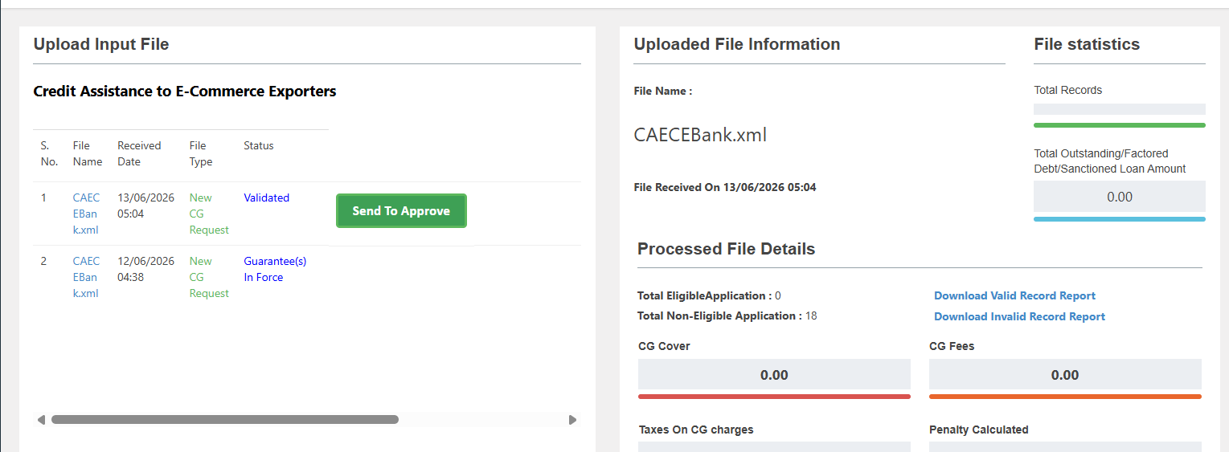

Case 2 - File contain both valid and invalid records
- Status will be processed and CG PAN will generate only for valid record

Case 3 - Re-pushing incorrect recorders by making corrections
- If re-pushed error record by correcting error - old error record will till exists in Invalid section

Case 4 - adding zero in front of master code
ConstitutionType and EntityType on adding code as 01 instead of 1 API is not showing any error

Case 5 - Invalid and Valid file will not be visible at NCGTC side on homepage as showing for other scheme

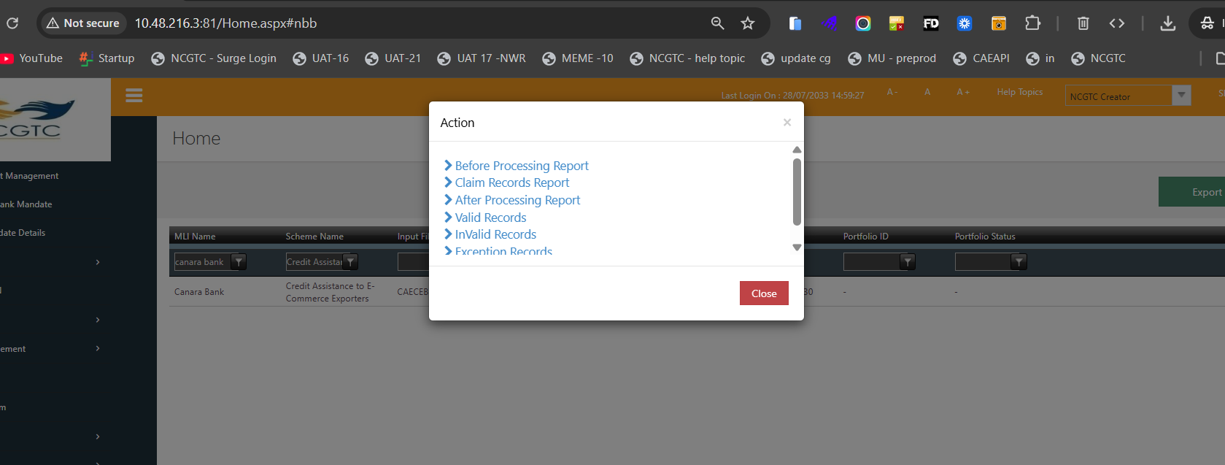

Case 6 - Format for Guaranty cover in pdf format is not proper

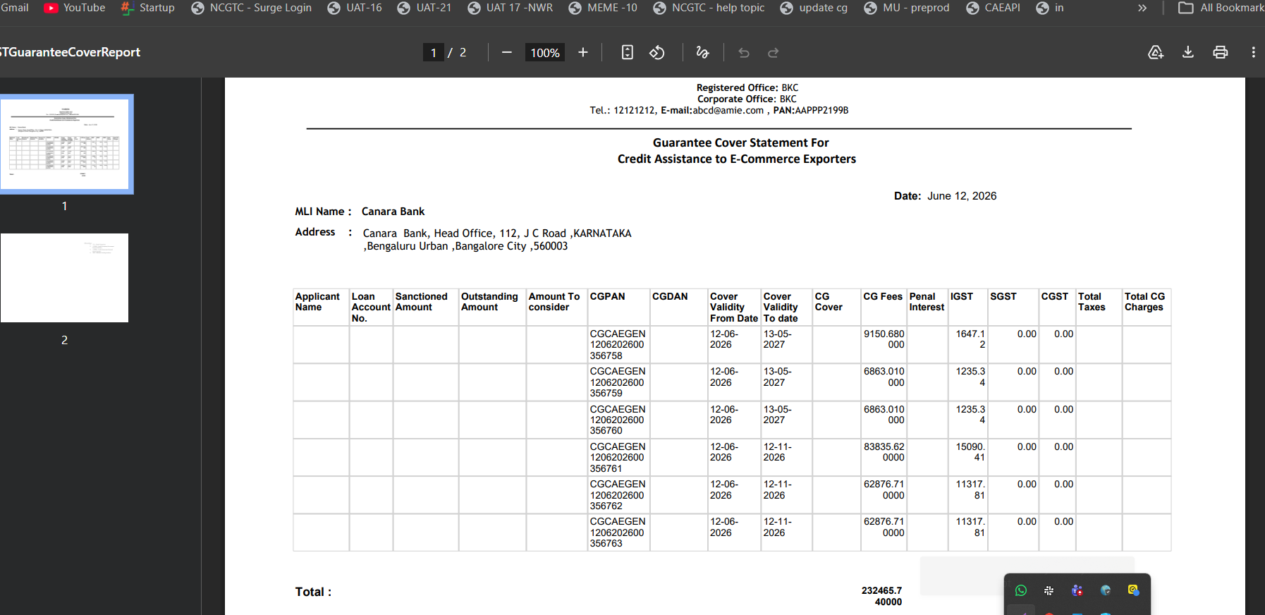

Added format of doccuemnt below kinldy review and let us know in case any modification needed

